PHYSICS PRACTICAL
NANABANYIN ESSEL
SM/SMS/10/0026
MED 111 GROUP 7
EXPERIMENT 9 30th September, 2010.
AIM: To verify Newton’s law of cooling for a liquid (water).
APPARATUS: Small calorimeter with fitting lid with two bored holes, stirrer, thermometer, clamp, stand and stopwatch.
DIAGRAM: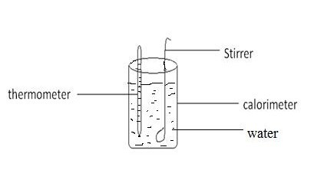
METHOD: Water was heated to boiling point. The calorimeter was placed on a bad conductor near an air conditioning unit. The water when reached 90$℃$ ,was transferred into the calorimeter and the lid with the stirrer and the thermometer fitted was fixed on the calorimeter. The cooling water was kept well stirred throughout the experiment and the temperature was recorded for a minute interval till the temperature reached $35℃$ and then a table of values was drawn as shown below. A curve of the table was drawn and also shown below.
TABLE OF RESULTS

time(t)$/min$ | temperature($θ$)/$℃$
0 | 90
1 | 86
2 | 84
3 | 82
4 | 80
5 | 79
6 | 77
7 | 76
8 | 74
9 | 73
10 | 71
11 | 70
12 | 69
13 | 68
14 | 66
15 | 65
16 | 65
17 | 63
18 | 62
19 | 61
20 | 60
time(t)$/min$ | temperature($θ$)/$℃$
21 | 60
22 | 59
23 | 58
24 | 57
25 | 56
26 | 55
27 | 55
28 | 54
29 | 53
30 | 52
31 | 51
32 | 51
33 | 50
34 | 50
35 | 49
36 | 48
37 | 48
38 | 47
39 | 47
40 | 46

time(t)$/min$ | temperature($θ$)/$℃$
41 | 46
42 | 45
43 | 45
44 | 44
45 | 44
46 | 44
47 | 43
48 | 42
49 | 42
50 | 41
51 | 41
52 | 40
53 | 39
54 | 39
55 | 38
56 | 38
57 | 37
58 | 37
59 | 37
60 | 36
61 | 36
62 | 35

GRAPH OF TEMPERATURE AGAINST TIME

TABLE WITH VALUES OF SLOPE AGAINST MEAN TEMPERATURE OF SURROUNDINGS
Slope (⁰c/min) | θ-θ₀ (⁰c)
2 | 56
2 | 46
1.42 | 36
0.83 | 26
0.59 | 16
0.56 | 6
Slope at 85⁰c $\frac{90-80}{0-5}$ = -2⁰c
Slope at 75⁰c $\frac{80-70}{5-10}$ = -2⁰c
Slope at 65⁰c $\frac{70-60}{10-17}$ = -1.42⁰c/min
Slope at 55⁰c $\frac{60-50}{17-29}$ = -0.83⁰c/min
Slope at 45⁰c $\frac{50-40}{29-46}$ =-0.59⁰c/min
Slope at 35⁰c $\frac{40-35}{46-55}$ =-0.56⁰c/min
θ – θ₀ = (Temperature at slope – Mean temperature of surroundings)

GRAPH OF SLOPES (⁰c/min) AGAINST TEMPERATURE (⁰c)

THEORY: A hot liquid loses heat to the surrounding when it is left to cool over a period of time. A graph of temperature against time of heat loss gives a curve known as cooling curve with a negative gradient.
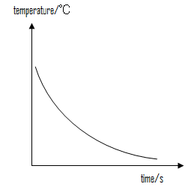
Newton’s law of cooling states that for a small temperature difference between a body and its surroundings, the rate at which heat is lost from a hot body as it cools down is directly proportional to the temperature difference between the hot body and the surrounding.
Mathematically
$\frac{Heat}{time}∝temperature difference$
$\frac{θ}{t}∝(θ-θo)$
$\frac{dθ}{dt}$
$\frac{dθ}{t}=k(θ-θo)$

$θ-θo$

Where θ is the temperature of the body
$θ_{0}$ is the temperature of the surrounding
k is a constant which is the slope
A graph of $\frac{dθ}{dt}$ against (θ-θ₀) is a straight line
OBSERVATION: From the first graph, it will be noted that there is a smooth curve which obeys Newton’s law of cooling. Also, the second graph is a straight line which proves that rate of change heat loss is directly proportional to any excess temperature at any instant.
SOURCES OF ERROR:
- The lid of the calorimeter was not fitted tightly causing heat loss through convection.
- The hole in the lid for the thermometer was quite big it enabled heat loss.
PRECAUTIONS:
- The calorimeter was placed on an insulator to prevent heat loss by conduction.
- The water was stirred continuously to ensure uniformity in the temperature of and ensure effective convection.
CONCLUSION: The graph is a straight line showing that the rate of loss of heat is proportional to the excess temperature at any instant.

